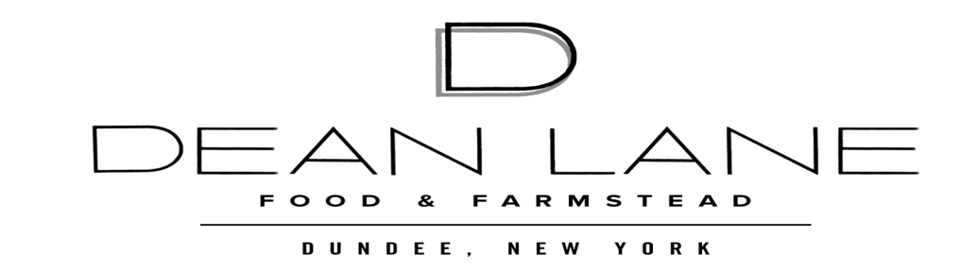

**Farmed and Foraged Dinner- Barnstormer Winery**

August 20, 2023

**Course 1- Farmer’s Board**

Local Cheese, Cured Meats, Seasonal Goodies

**Course 2- Butter Poached Lobster**

Oven Dried Tomatoes, Greens, Champagne Vinaigrette, Spiced Cashew Dust

**Course 3- Confit Cantonese Duck**

Crispy Polenta, Wilted Greens

**Course 4- Blueberry Shortcake**

Buttermilk Biscuit, Blueberry Compote, Late Harvest Riesling Whipped Cream